Registry of Births, Deaths and Marriages Victoria

Guarantor

Change of name

Births, Deaths and Marriages Registration Act 1996

# Photo and signature

If you have not supplied an identity document that proves the link between your photo and your signature, you must supply a certified photograph and signature.

## Photograph

Professional passport photos are preferred. These are available from most Australia Post outlets, retail photo processing outlets and some chemists.

If you are supplying your own photo, it must:

* be no more than 6 months old
* show only head and top of shoulders
* be clear, in focus, and of good quality colour, brightness and contrast
* be between 35mm and 40mm wide and between 45mm and 50mm high
* be printed on photographic paper, with no marks on the image
* show you without any hat or other head covering

If you wear a head covering for religious reasons, the photo must show your face from bottom of chin to top of forehead and both edges of your face

* be attached to this form with a paperclip (do not staple)
* be signed on the back by a Guarantor along with your name and signature.

Example photograph. 
It shows photograph dimensions: between 35mm and 40mm wide, and between 45mm and 50mm high. 
Head/face dimensions: between 32mm and 36mm high.


## Guarantor

You must have a Guarantor endorse your photo.

The Guarantor must:

* not be related to you by birth or marriage
* not be a domestic partner or in a registered domestic relationship with you
* not live at the same address as you
* have known you for at least 12 months
* be 18 years of age or over.

**The Guarantor must:**

* endorse the back of the photo by writing ‘This is a true photo of (the applicant’s full name)’ and signing their own name (see illustration)
* complete and sign the following Guarantor’s statement.

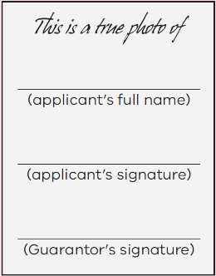

# Guarantor’s details

|  |  |
| --- | --- |
| Family name: |  |
| Given name: |  |
| Other given name(s): |  |
| Date of birth: |  |

## Address

|  |  |
| --- | --- |
| Street number and name: |  |
| Suburb/Town: |  |
| State: |  |
| Postcode: |  |
| Country: |  |
| **Telephone number:** |  |
| **Email address:** |  |
| How do you know the applicant? (eg. doctor, lawyer, friend): |  |
| How long have you known the applicant? | years,       months |

# Guarantor’s statement

I declare that the information I have provided is true and correct to my knowledge and that I qualify to be a Guarantor for the person changing their name in this application.

I understand that the Registry of Births, Deaths and Marriages Victoria may make enquiries with any organisation or individual to verify the information I have provided on this form.

|  |  |
| --- | --- |
| Guarantor’s signature: |  |
| Date (DD/MM/YYYY): |  |